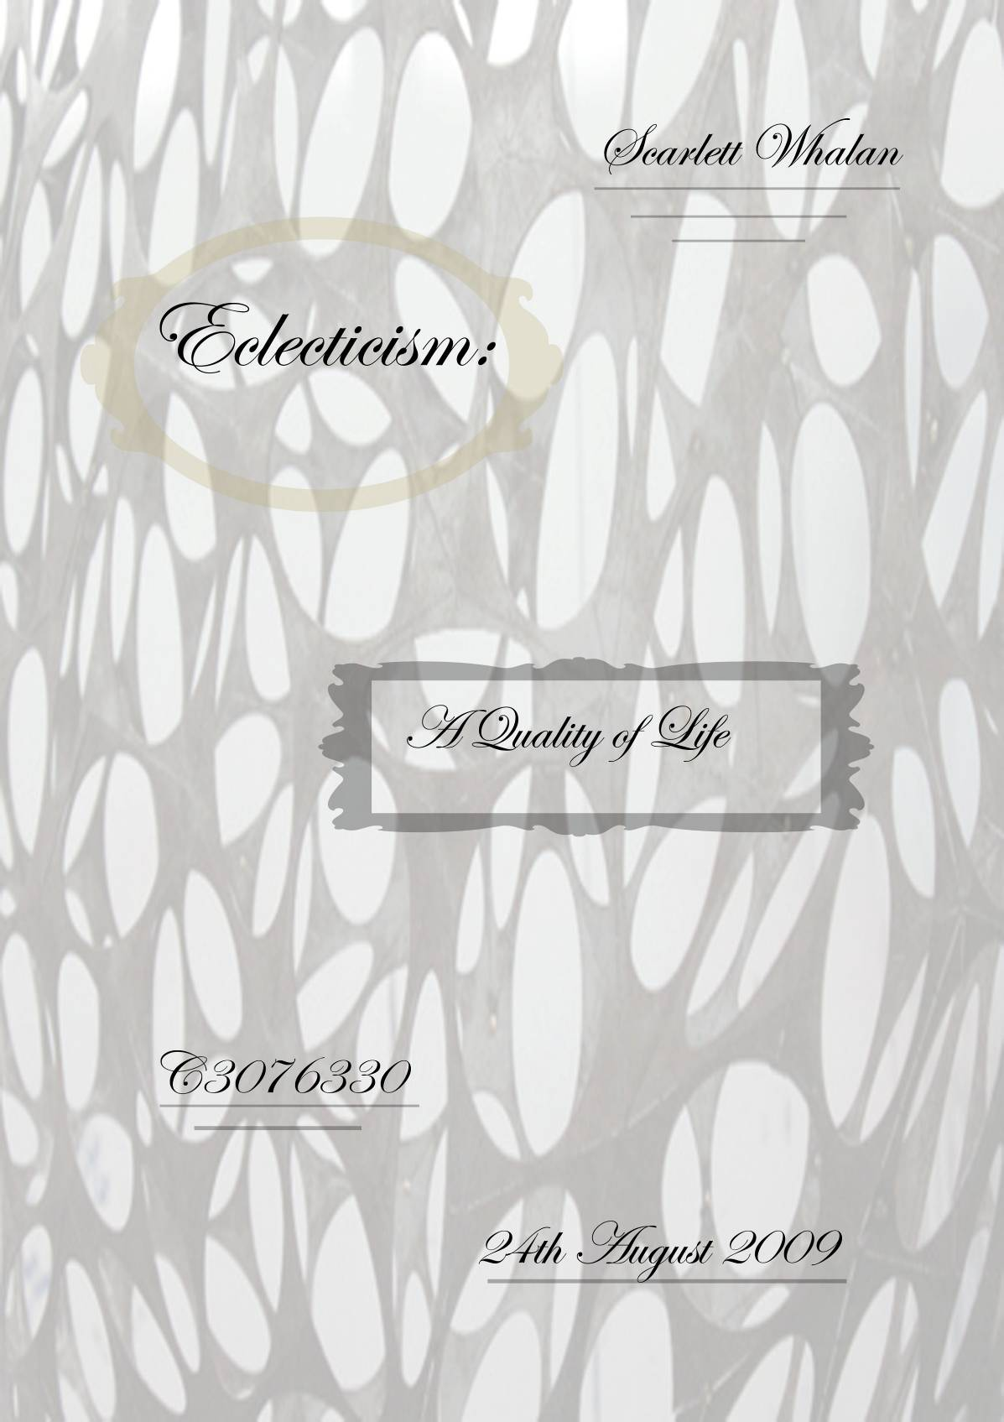

1. Abstract

Architecture is a discipline that moulds together both science and art harmoniously into structures, thus a building is born from a creative vision and becomes a tangible structure. In order to attain, this tangible structure, guidelines ought to be respected during the design process.
- Architecture should be sustainable in terms of product usage. A material should be selected on functionality not on aesthetics alone.
- Material, generally, should be left in its natural form or state thus allowing us to appreciate each individual material within the building.
- Technology should not govern a design but rather be integrated within it when required by the individual project.
- The primary concern for an architect is to create spaces that are designed to their specific purpose producing the appropriate atmosphere and avoiding generic spaces.
- Site and context should be considered and integrated into the design.

Table of Contents

- Abstract Page 2.

- Background to Personal Design Theory Page 4.

- Similarities and Differences Page 5-7.

- Ramifications Page 8-9.

  - Brief

  - Concept

  - Context

  - Site

  - Plan

  - Sections

  - Elevations

  - Materials

  - Sun control

  - Elevations

- Conclusion Page 10.

- Bibliography Page 11-12.
2. Background to Personal Design Theory

Society is constantly exposing each individual to design in our day to day life, some more than others and while some reject design others embrace it. During the last ten years of my life to date I have become increasingly aware of design surrounding our lives and its influences on the quality of life. Gradually I have come to believe that our surrounding environment and proportion of creativity within our lives directly affects the individual’s quality of life.

In 2003 I travelled to Canada here I was transfixed by the vastly different landscape. The landscape seemed to hold magical qualities, the surrounding cottages and buildings were so different from Australian suburbia. They appeared to blend in with the environment half exposed and half neatly tuck away. The majority of buildings, especially older structures, used the timber from the surrounding land as the building material. I was particularly intrigued by the log buildings as this was fist time I had experienced them. When I returned home I began comparing the Canadian landscape and buildings to ours in Australia. That trip was the beginning of my architectural interest and full embracement of design in our daily lives.

Since then I have travelled to more countries, New Caledonia, Italy, France, Portugal and America in each of these countries I was fascinate by their buildings and environment. I was constantly comparing each country with Australia’s environment and structures. This continual evaluation has immensely increased my admiration of the Australian landscape and illuminated various types of design, which I am eager to integrate with Australian culture.

My design values have been further increased since attending university with the introduction international architects such as: Mies Van der Rohe and Phillip Johnson and Australian architects; Peter Stuchbury, Stuart Tanner and Troppo Architects. These architects have revealed how imagination and science can be woven together forming liveable art, architecture.

3. Similarities and Difference to an Established Movement: Eclecticism

Eclecticism is a subculture of the Post-Modern era (1970-1980) and along with classicism; these two movements yearned to reject the strict rules and regimentation of modern architecture. Eclecticism denotes the return to complexity within architecture by combining historical ideals and past movements into innovative architecture. Although eclecticism draws visual parrels to past movements it is not revivalism as it does not merely copy styles but moulds them into designs, which reflect modern culture.

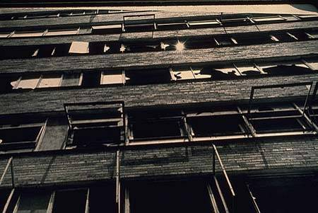
The eclectic movement was brought about by various events which coincided; globalisation, rise in technology and new materials and in particular the pitfalls of modernism were exposed. Charles Jencks writes that modern architecture “has all the faults of an age trying to reinvent itself totally on rational grounds”. The main shortcoming of modern architecture was the emotional detachment from the clients and the failure of their social ideologies, as displayed in the Pruitt-Igoe Scheme, Missouri.
Figure 1: Pruitt-Igoe Scheme

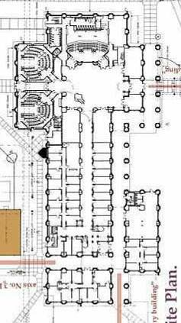
Previously an architect had to travel to experience different cultures and their buildings, however due to globalisation this was no longer the case. More architects had access to various styles and movements which influenced their designs, resulting in structures being built that reflected other cultures.

The architect John Outram draws heavily from different cultures and these influences are clearly expressed within his work, especially the Computational Studies building, Rice University, Houston, Texas, USA. Outram’s direct reference to Greek religion is portrayed through the plan of this building. It is made up of two Greek crosses; the Main Hall is the middle of the larger cross, and the West Hall is situated at the center of the smaller cross. Roman influences are illuminated by the use of a hypostyle; a regular grid of columns. The clearstory windows are derived from gothic architecture and the interior decoration, particularly colours draws strong parallels to Egyptian embellishments, while the ceiling is reminiscent of the Byzantine era. Individually each of these are from different cultures but Outram has combined them expertly into a modern structure, highlighting his eclectic nature. “Outram believes in an architecture of ideas and themes and believes that buildings and their inhabitants interact in fundamental and subconscious ways.” While Outram is a true eclecticist he does not purely fixate on aesthetics, the planning of spaces is one of his a primary concerns revealed in the entrance hallway. The high heavily decorated ceiling, clearstory windows and colossal pillars generate a space which is both awe-inspiring and grandiose leaving the responder feeling a sense of pride to be within its walls. Hence his understanding of volumes and incorporation of aesthetics simultaneously produce the appropriate atmosphere.
Figure 2: Plan of the Computational Studies Building, depicting cross formation and hypostyle.
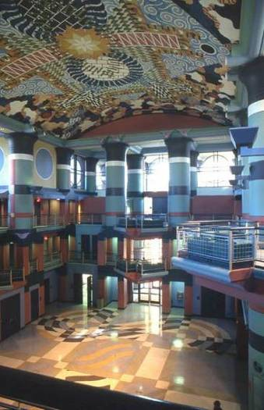
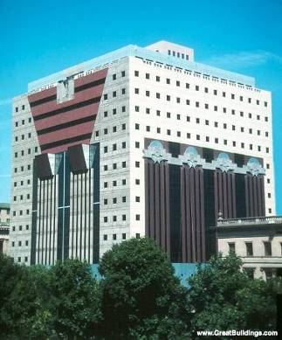
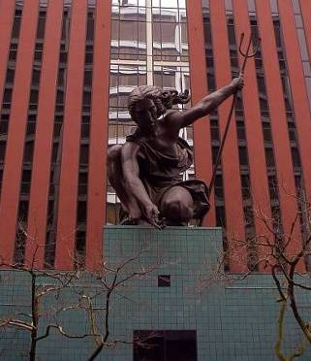
Michael Graves first large scale building was the Portland Public Services Building, in Portland Oregon 1980. This building depicted Graves’ post-modern ideals of decoration through symbolism and colour. “A significant architecture must incorporate both internal and external expressions. The external language, which engages inventions of culture at large, is rooted in a figurative, associational and anthropomorphic attitude." Graves integrates the city of Portland itself with in the design of the building, symbolized by his interpretation of the Lady Commerce from the Portland City seal situated above the main entrance. His eclectic nature is again depicted by the neo-classical form of the building organized in a three-part division of base, body, and head. Graves’ effort to diverge from the modernist white canvas is illustrated by his exterior treatment of colour, using vibrant primary hues. While Graves Portland Building adheres to his design principles; external decoration as a figurative element, it is largely considered a disappointment. Due to its flawed planning, tiny windows, cramped workspaces, poor construction and exterior brashness, the Portland community have failed to embrace this structure as their own. Although Graves’ building was designed to relate to context in retrospect the only aspect which achieved this were the materials and Lady of commerce. This is a key example of why context and site should be integrated into the design.
Figure 3: Entrance hall illustrating various decoration and volume of the space.
Figure 4: Portland Building
Figure 5: Lady of Commerce above Entrance

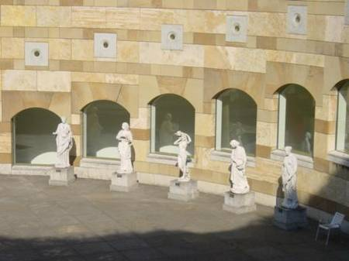
James Stirling and Michael Wilford were the architects who designed the Staatsgalerie in Stuttgart, Germany 1984. James Stirling’s eclectic character is displayed in his ability to reinterpret the past in new ways, producing a collage of references.
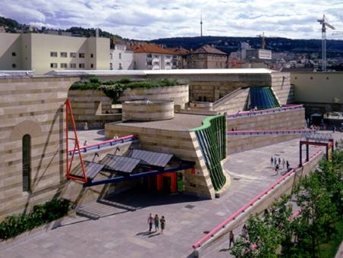
This reference to existing buildings both old and new denotes the return of complexity to architecture. The Staatsgalerie draw directly from Shinkel’s Altes Museum in Berlin, however the enclosed rotunda is replaced by an open circular courtyard. Not only do Stirling and Wilford reference historic buildings but they also allude to modern and late modern architecture.These Modern and late modern references are also contextual buildings. Mies van der Rohe, Le Corbusier, and J. J. P. Oud all have buildings which have been alluded to in the rear elevation of the chamber theater. While Stirling is now considered an eclectic architect his earlier where of a brutalist style and therefore some of his early design principles have evolved to become an integration of the two styles. In an article written in 1979 for Contemporary Architects, Stirling said “I believe that the shapes of a building should indicate—perhaps display—the usage and way of life of its occupants, and it is therefore likely to be rich and varied in appearance, and its expression is unlikely to be simple …. And so the particular way in which functional-symbolic elements are put together may be the art in the architecture.” The Staatsgalerie is very diverse in its eclectic notions, it is a melting pot of many styles yet it is uniquely it’s own and contemporary. This is achieved through careful design and the use of many materials in their relatively unadorned state
Figure 6: Historical References with the Courtyard
Figure 7: Gallery Entrance

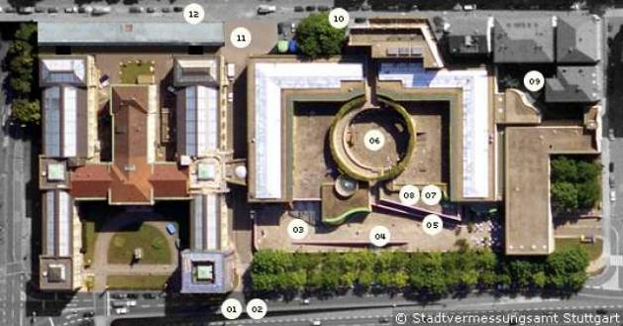
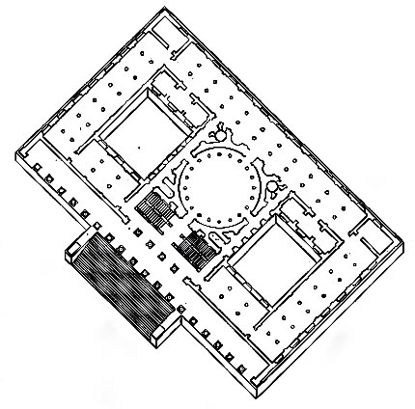
Figure 8: Floor Plan of the New State Gallery
Figure 9: Floor Plan of Altes Museum
4. Ramifications

This movement, of eclecticism, identifies with my design principles mainly through ideologies as opposed to direct design guidelines. As I believe that by learning from both our own and others past mistakes and success we become more competent architects. This is why my personal approach to design borrows ideals from several movements. For example materials in there unadorned state is a principle of brutalism; while integration of context and site aligns with Regionalism and a primary concern of spaces is modernist principle. However as eclecticism borrows from other movements these principles are also seen in eclectic architecture, with added historical references and embellishments. In order to achieve architecture which integrates science and art into tangible structures I believe this is method of design is vital.

  - The Brief: will be discussed with the client so that they can highlight the elements which they are most concerned with. This will also allow ‘the architect’ to begin to distinguish the client’s individual lifestyle, taste and personality, so that a design can be reached which satisfies the client.

  - Context: The context involves the specific site, overall area of site (city, state, and country), time or era, the brief and the clients themselves. These must be analysed individually and combined to produce a design, which effectively address each of these aspects.

  - Concepts: The concepts should be derived from site inspiration and/or the interest of the client, which define their life.

  - Site: planning should only be attempted after the site has been fully analysed to discern the advantages and disadvantages of the site. This includes, immediate surroundings, distant surrounding, site size, topography and the site environment; soil, wind, water, sun, temperatures. The planning then should aim to increase the site assets, while overcoming the sites weakness to fully showcase the architecture.

  - Plan: The site, concept and client’s brief should govern the plan of the building.

  - Sections: Should be generated by the plan and designed in accordance with the concept, site, brief and methods of sun control.

  - Elevations: Once the plan and section have been solved or decided the elevations should happen naturally. The elevations are largely dictated by the context, site and sun control. The material selection will effect the elevation visually, however should not generally affect its form.

  - Materials: The materials used should be selected not purely for aesthetics but also for function. Each material that is used should enhance the design and have direct reasoning behind it. In terms of sustainability the material should be relatively local e.g. not transported vast distances, usage of precious resources should be kept to a minium and during construction materials should be use to their full potential to avoid waste.

  - Sun Control: While northern light is the desired light in the southern hemisphere I believe that it is important not to disregard the other directions of light, as the can provide moments enjoyment depending on the time of day and year. Therefore sun control should be vastly considered within the design to create various spaces where each of these forms of light can be enjoyed. Sun control should be used in a sustainable way reducing the use of lights, heating and cooling where possible.

4.10 Elevations: fenestrae’s should follow the form of the building; they may be exaggerated, hidden, embellished or minimal as long as they do not hinder the aesthetic qualities, they should be integrated seamlessly from the interior to exterior of the design.

5. Conclusion

In order to create a building that integrates sustainability, functionality and art, the architect must look beyond their context into a variety of past and present cultures, movements and designs to employ these for inspiration. By looking back on architectural history we as architects are able to learn from other’s triumphs and failures, thus increasing our knowledge base. The eclectic architect draws on many styles and integrates them into their designs, hence celebrating complexity. This is why my personal approach to design borrows ideals from several movements. They analyse past movements and take ideals that appeal to them and leaving those that don’t to create a movement which, in a sense if free from rules and guidelines that have hindered pervious movements. However this of lack restraint, while liberating can be detrimental to the design if the architect is unable to efficiently mould the different ideas into a harmonious design.

6. Bibliography

- Michael J Oswald, ‘Post-Modernism: Eclecticism,’ in Michael Oswald (eds), Movements in Twentieth Century Architecture, A reader in Architectural Theory, Sydney: Archadia Press, 2000, pp 109.
- Robert Venturi, ‘Complexity and Contradiction in Architecture,’ in Michael Oswald (eds), Movements in Twentieth Century Architecture, A reader in Architectural Theory, Sydney: Archadia Press, 2000, pp 111-113.
- Talbot Hamlin, ‘The Rise of Eclecticism in New York,’ The Journal of the Society of Architectural Historians, 11, 21(may, 1952): 3-8. Accessed from http://wwww.jstor.org/stable/987657, on the 14 August 2009.
- Richard W. Longstreth, ‘Academic Eclecticism in American Architecture,’ Chicago Journals; Winterthur Portfolio, 17, 1(Spring, 1982): 55-82. Accessed from http://wwww.jstor.org/stable/1180764, on the 14 August 2009.
- Charles Jencks, ‘The Death of Modern Architecture,’ in Michael Oswald (eds), Movements in Twentieth Century Architecture, A reader in Architectural Theory, Sydney: Archadia Press, 2000, pp 110.
- Mario Carpo, ‘Architecture Theory, Interdisciplinary and Methodological Eclecticism,’ The Journal of the Society of Architectural Historians, 64, 4(December, 2005): 425-427. Accessed from http://wwww.jstor.org/stable/25068195, on the 14 August 2009.
- Keith D. Cooper, ‘What was he Thinking,’ Anne and Charles Duncan Hall (n.d), http://www.cs.rice.edu/~keith/DuncanHall/. Accessed 17 August 2009.
- Robert Maxwell, ‘The Place the Impossible dream was realized,’ John Outram Associates (updated January 2001), http://www.johnoutram.com/projectsmenu.html, Accessed 17 August 2009.
- Cynthia Davison, ‘Michael Graves,’ Architectural Digest, 64, 1(January 2007): 129.
- Michael Graves, ‘Michael Graves: Buildings and Projects 1966-1981,’ New York: Rizzoli International Publications, 1982, p.11
- Brian Libby, ‘reevaluation Postmodernism,’ Architecture Week, 1, 2 (5 June 2002):1-2. Access from http://www.architectureweek.com, 18 August 2009.
- D. Sudjic, Norman Foster, Richard Rogers, James Stirling, ‘New Direction in British Architecture,’ New York: Thames and Hudson, 1987, pp. 69-70.
- ‘James Stirling: Architect Biography,’ Famous Architects (updates 8 July 2008), http://architect.architecture.sk/james-stirling-architect/james-stirling-architect.php, accessed 18 August 2009.
- Tiffany Sutton, ‘Review: Untitled,’ The Journal of Aesthetics and Art Criticism, 61, 3(Summer, 2003): 306-307. Accessed from http://wwww.jstor.org/stable/1559185, 18 August 2009
- James Stirling, ‘The Monumental Tradition,’ The MIT Press: Perpecta, 16(1980): 33-49. Accessed from http://wwww.jstor.org/stable/1567022, 18 August 2009
- Timm Knief, ‘James Frazer Stirling,’ Arch inform (updated 21 May 2009), http://www.archinform.net/arch/293.htm, accessed 18 August 2009.
- Carroll L. V. Meks, ‘Creative Eclecticism,’ The Journal of the Society of Architectural Historians, 12, 4(December, 1953): 15-18. Accessed from http://wwww.jstor.org/stable/987646, 14 August 2009.
- Ignasi De Sola-Morales, ‘The Origins of Modern Eclecticism: The Theories of Architecture in Early Nineteenth Century France,’ The MIT Press: Perspecta, 23(1987): 120-133. Accessed from http://wwww.jstor.org/stable/1567112, 14 August 2009.
- Heinrich Klotz, ‘Architecture as Ficition: The Concept of Postmodernism,’ in Michael J. Ostwald (eds), Movements in twentieth Century Architecture: A Reader in Architectural Theory, Sydney: Archadia Press, 2000, pp.119-122.
- David Harvey, ‘Postmodernism in the city: Architecture and Urban Design,’ in Michael J. Ostwald (eds), Movements in twentieth Century Architecture: A Reader in Architectural Theory, Sydney: Archadia Press, 2000, pp.123-126.

Ostwald, ‘Post-Modernism: Eclecticism,’ p.109
Venturi, ‘Complexity and Contradiction in Architecture,’ p111-113
Hamlin, ‘The Rise of Eclecticism in New York,’ p3-8
Longstreth, ‘Academic Eclecticism in American Architecture,’ p55-82
Jencks, ‘The Death of Modern Architecture,’ p110
Carpo, “Architecture Theory, Interdisciplinary, and Methodological Eclecticism,’ 425-427
Cooper, ‘What was he thinking’.
Maxwell, ‘The Place the Impossible Dream was Realised’.
Davisons, ‘Michael Graves,’ p.129
Graves, ‘Michael Graves: Buildings and Projects 1966-1981,’ p.11
Libby, ‘Re-evaluating Postmodernism,’ p. 1-2
Norman, Rodgers, Stirling, ‘New Direction in British Architecture,’ p. 69-70
‘James Sirling: Architect Biography’
Sutton, ‘Review,’ p306-307
Stirling, ‘The Monumental Tradition,’ p.39-39
Knief, ‘James Frazer Striling’.

